Alex Witt

Documentation for completing AWS migration

Upon migrating different APIs, Gateways, and instances these various AWS apps require redeployment on new accounts or regions. This is documentation showing how to redeploy various applications. **API Gateway contains a simple “Deploy API” for the entire gateway:  
  
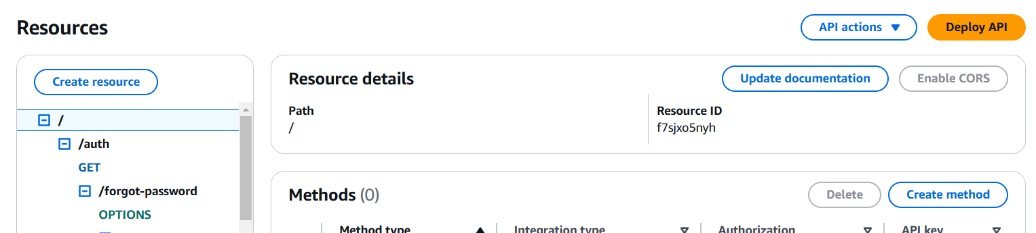**

**Each Lambda Requires a “Restore” in order to continue functioning:  
  
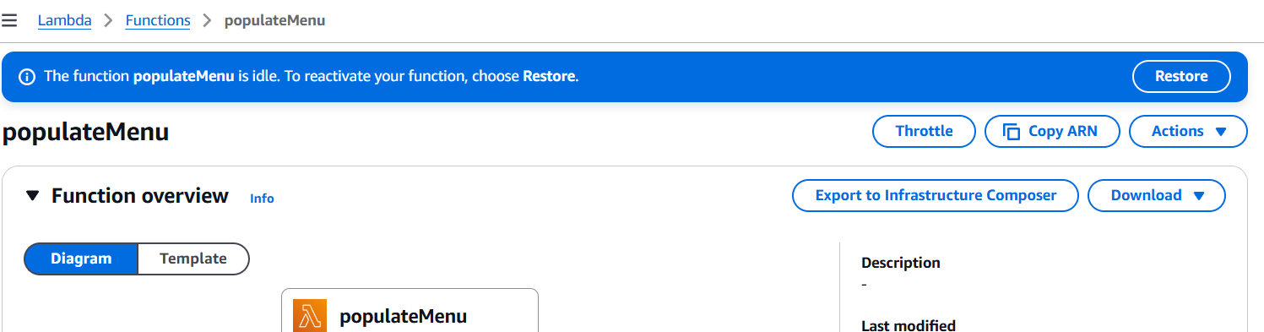  
  
Restoring can take a few minutes per lambda:  
  
  
EC2 Instances require a restart upon migration:  
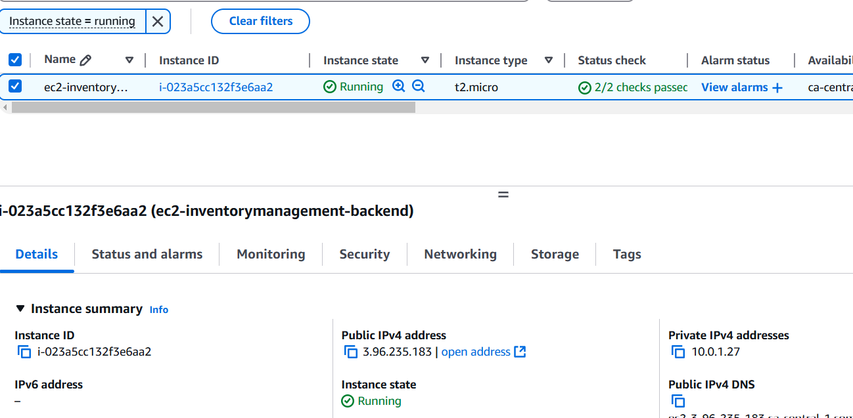**

**S3 Storage, This cannot be migrated as other services, however data can be transferred and copied over to other AWS accounts and will function as before.  
  
Textract requires no migration since storage is typically handled in S3, Textract is a service that is offered but does not store or allow changes by users.**